

**Lab 7: *Cyber Attacks and Hacker’s Techniques* (3%)**

**Overview:**

This lab will introduce you to cyber-attacks and teach you real criminal techniques from real criminals.

***Understand their techniques, though do not imitate them***.

**Objective:**

1. To understand hacker techniques to circumvent access controls.
2. To demonstrate typical web site mistakes that can be exploited by hackers.
3. To demonstrate how javascript injection can change variables and intent of web applications

Note: substitute your MySeneca Username where MSU is given in a filename.

**The Lab Activities**

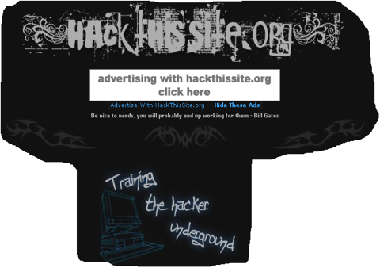

For this lab we will be using the web site ‘hackthissite.org’. The goal of the site is to teach hacking techniques.

"Hack This Site” is a free, safe and a legal training ground for hackers to test and expand their hacking skills". As students of ethical hacking, the site provides an excellent opportunity safe from prosecution. However, you should not assume you are safe in leaving personal information on the site. There is also the possibility that a member of the hacker community may be able to access personal information and use it for personal advantage.

To be able to use ‘hackthissite.org’ you will need to register.

* Navigate to ‘hackthissite.org’ and register. I recommend you **do not reveal your real name or email address** when registeringand **USE TOR** (available here:<https://www.torproject.org/>) for visiting the website.

NB: You will need a ‘fake’ e-mail account to receive the activation e-mail that is set after you have successfully registered.

* After creating your account, log in. Then, on the upper left of the main page, in the C**hallenges** section, click "**Basic Missions**".
* The Challenges are organized as "hacking missions". Each mission gives a brief description of what you are supposed to do. You should see a page with eleven (11) basis missions labelled “Basic 1”, “Basic 2”, etc.

**NB: Each mission is progressively more difficult and requires you to understand how the source code works in a client \server environment. Try to solve the mission on your own without doing a Google search. Think and act like a hacker!!**

* This lab requires that you solve the first seven (7) basic missions and the third realistic mission (Peace Poetry: Hacked). When you have completed ***each level*** take a screen shot – ensure your screenshot has:
  + Your custom desktop visible
  + Your HackThisSite username visible and the “Congratz” (See image below – in this instance I have redone Basic 1)

.

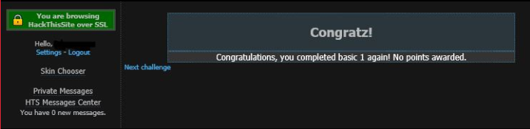

**Lab Assignment Report Write-up**

As there is not template, create your own report template using the previous templates as a basis.

Save all the screenshots in the report, save your report as MSU_L7.docx or pdf.

**Deliverable**

To submit your lab assignment report to Blackboard.

Note:

* Submissions deadlines are given through the lab submission link.
* Late labs will be assigned a grade of ‘0’..
* Late labs still need to be satisfactorily completed and submitted by the end of Week 12 to meet BTN710’s Promotion Requirements.